**Housing prices in North Carolina per Counties**

Dataset:

The dataset features 100 North Carolina counties and their daily house prices for 294 days in the year 2000. The dataset was transposed into rows. The days with no house price were removed for their respective counties.

Analysis:

To explore the data, we start with looking at the house prices in a county throughout the year.

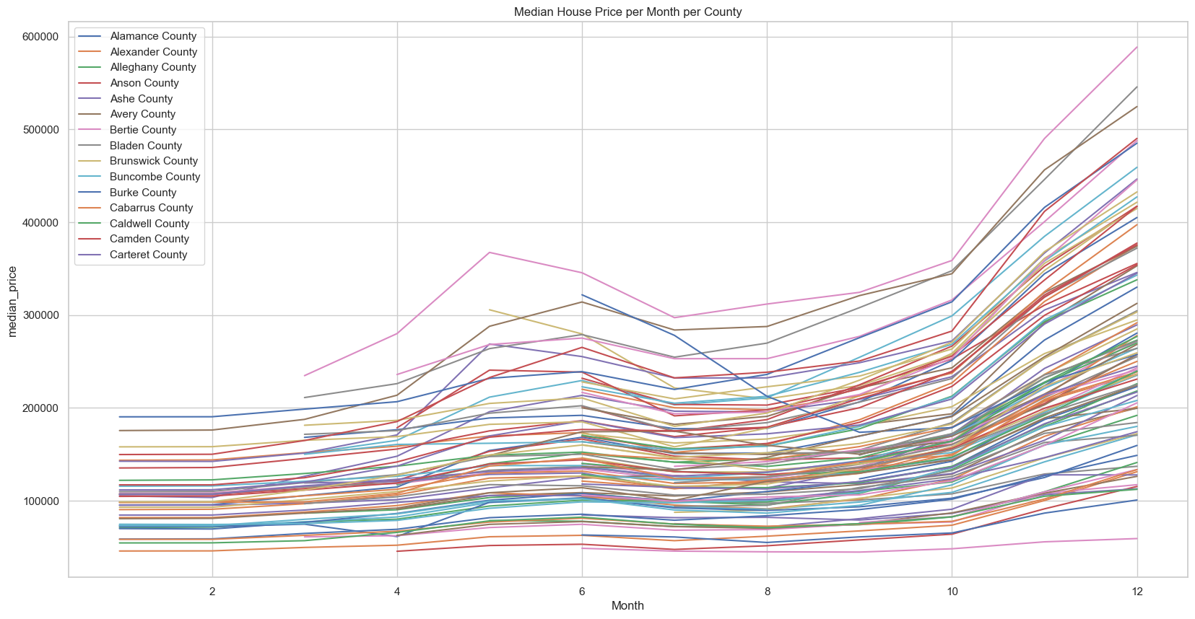

As shown, above most counties have seen an increase in housing prices throughout the year.

Next, we assessed the percent increase in house prices that each county experienced throughout the year and identified the top 10 counties by percent increase and the bottom 10 counties by percent increase.

|  |  |  |  |  |
| --- | --- | --- | --- | --- |
| **Top 10 county** | **percent_increase** |  | **Bottom 10 county** | **percent_increase** |
| Clay County | 246.1980798 |  | Perquimans County | -19.98739146 |
| Ashe County | 228.9485059 |  | Bertie County | 21.50756443 |
| Watauga County | 227.4157125 |  | Bladen County | 32.32825602 |
| Polk County | 220.9191463 |  | Hertford County | 33.22070225 |
| Montgomery County | 218.7037664 |  | Brunswick County | 36.52398836 |
| Carteret County | 213.2503165 |  | Pasquotank County | 47.27831991 |
| Macon County | 209.1662981 |  | Camden County | 53.29099109 |
| Yancey County | 207.0181654 |  | Hoke County | 57.36061118 |
| Buncombe County | 204.4340733 |  | Jones County | 59.62211305 |
| Currituck County | 198.7752785 |  | Gates County | 60.47151734 |

Then we looked at the distribution of the percent increase overtime and identified that house prices increased by 100% or more for 57% of the counties in our dataset.

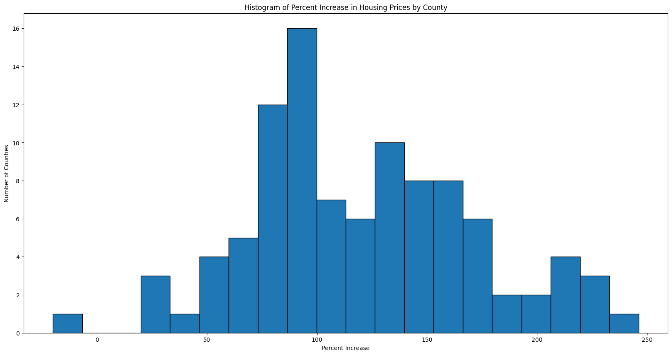

Lastly, we try to identify if the highest increases occurred in counties that are within a metro area.

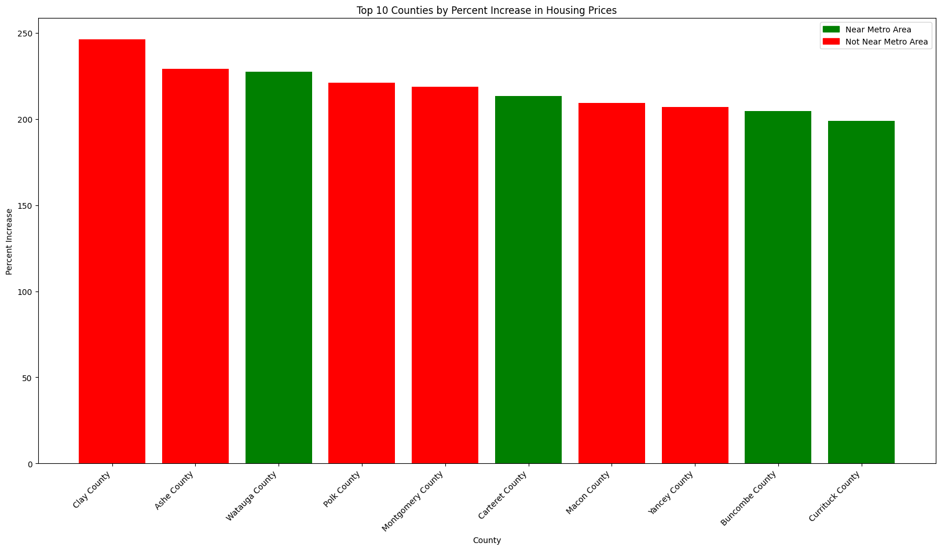

As shown above, only 4 of the counties featured in the top 10 are within a metro area. Most of the increases are occurring outside of the metro areas in North Carolina